**TITLE: Process /Thread Creation and Termination**

**THEORY:**

Process creation in Linux uses fork() to create a new process, and exit() terminates it. Threads are created using pthread_create() and terminated using pthread_exit(). These concepts allow multitasking and efficient resource management in the operating system.

1. **WAP in C to demonstrate the process creation and termination in Linux.**

**Program:**

#include <stdio.h>

#include <unistd.h>

#include <stdlib.h>

#include <sys/wait.h>

int main() {

pid_t pid = fork();

if (pid < 0) {

printf("Fork failed\n");

return 1;

}

else if (pid == 0) {

printf("This is the child process. PID: %d\n", getpid());

exit(0);

}

else {

printf("This is the parent process. PID: %d\n", getpid());

wait(NULL); // Wait for child process to terminate

printf("Child process terminated. Parent process exiting.\n");

}

printf("\nLab No.: 2\n");

printf("Name: Suresh Dahal\n");

printf("Roll No.: 23\n");

return 0;

}

**Output:**

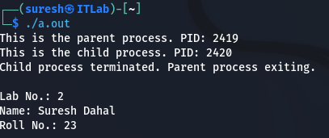

1. **WAP in C to demonstrate the thread creation and termination in Linux.**

**Program**

#include <stdio.h>

#include <stdlib.h>

#include <pthread.h>

void* threadFunction(void* arg) {

printf("This is the thread. Thread ID: %ld\n", pthread_self());

pthread_exit(NULL);

}

int main() {

pthread_t thread;

if (pthread_create(&thread, NULL, threadFunction, NULL) != 0) {

printf("Thread creation failed\n");

return 1;

}

pthread_join(thread, NULL);

printf("Thread terminated. Main program exiting.\n");

printf("\nLab No.: 2\n");

printf("Name: Suresh Dahal\n");

printf("Roll No.: 23\n");

return 0;

}

**Output**

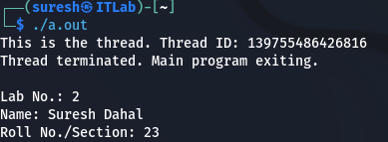

**TITLE: Simulation of IPC Techniques**

**THEORY:**Inter-Process Communication (IPC) allows processes to exchange data and synchronize execution. Common IPC techniques include **shared memory** and **message passing**.

* **Shared Memory:** Multiple processes access a common memory segment for fast communication. Synchronization mechanisms like semaphores prevent data conflicts.
* **Message Passing:** Processes communicate by sending and receiving messages using system calls like msgsnd() and msgrcv(), ensuring controlled data exchange.

These techniques are essential for coordinating tasks in multi-process systems.

1. **WAP in C to simulate shared memory concept for IPC.**

**Program**

#include <stdio.h>

#include <stdlib.h>

#include <sys/ipc.h>

#include <sys/shm.h>

#include <string.h>

#include <unistd.h>

#define SHM_SIZE 1024 // Shared memory size

int main() {

key_t key = ftok("shmfile", 65);

int shmid = shmget(key, SHM_SIZE, 0666 | IPC_CREAT);

if (shmid == -1) {

perror("shmget failed");

return 1;

}

char *shared_memory = (char *)shmat(shmid, NULL, 0);

if (shared_memory == (char *)(-1)) {

perror("shmat failed");

return 1;

}

printf("Writing to shared memory...\n");

strcpy(shared_memory, "Shared Memory!");

printf("Data written: %s\n", shared_memory);

shmdt(shared_memory);

printf("\nLab No.: 3\n");

printf("Name: Suresh Dahal\n");

printf("Roll No: 23\n");

return 0;

}

**Output**

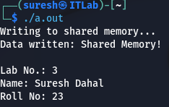

1. **WAP in C to simulate message passing concept for IPC.**

**Program**

#include <stdio.h>

#include <stdlib.h>

#include <sys/ipc.h>

#include <sys/msg.h>

#include <string.h>

#define MAX 100

struct message {

long msg_type;

char msg_text[MAX];

};

int main() {

key_t key = ftok("msgqueue", 65);

int msgid = msgget(key, 0666 | IPC_CREAT);

if (msgid == -1) {

perror("msgget failed");

return 1;

}

struct message msg;

msg.msg_type = 1;

strcpy(msg.msg_text, "Hello World!");

if (msgsnd(msgid, &msg, sizeof(msg.msg_text), 0) == -1) {

perror("msgsnd failed");

return 1;

}

printf("Message sent: %s\n", msg.msg_text);

printf("\nLab No.: 3\n");

printf("Name: Suresh Dahal\n");

printf("Roll No.: 23\n");

return 0;

}

**Output**

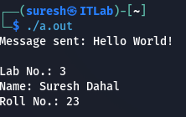

**TITLE: Simulation of Process Scheduling Algorithms**

**THEORY**

Process scheduling algorithms manage CPU execution to optimize performance. Common types include **FCFS**, **SJF**, **Round Robin**, and **Priority Scheduling** (preemptive/non-preemptive). The goal is to minimize waiting time, turnaround time, and response time while ensuring fair CPU utilization.

* 1. **WAP in C to simulate FCFS CPU Scheduling Algorithm**

**Program**

#include <stdio.h>

void findWaitingTime(int processes[], int n, int bt[], int wt[]) {

wt[0] = 0; // Waiting time for the first process is 0

for (int i = 1; i < n; i++) {

wt[i] = bt[i - 1] + wt[i - 1]; // Waiting time for other processes

}

}

void findTurnAroundTime(int processes[], int n, int bt[], int wt[], int tat[]) {

for (int i = 0; i < n; i++) {

tat[i] = bt[i] + wt[i]; // Turnaround time = Burst time + Waiting time

}

}

void findAverageTime(int processes[], int n, int bt[]) {

int wt[n], tat[n];

findWaitingTime(processes, n, bt, wt); // Calculate waiting time

findTurnAroundTime(processes, n, bt, wt, tat); // Calculate turnaround time

float total_wt = 0, total_tat = 0;

printf("\nProcess\tArrival Time\tBurst Time\tWaiting Time\tTurnaround Time\n");

for (int i = 0; i < n; i++) {

total_wt += wt[i];

total_tat += tat[i];

printf("%d\t%d\t\t%d\t\t%d\t\t%d\n", processes[i], 0, bt[i], wt[i], tat[i]);

}

printf("\nAverage Waiting Time: %.2f", total_wt / n);

printf("\nAverage Turnaround Time: %.2f", total_tat / n);

}

int main() {

int n;

printf("Enter the number of processes: ");

scanf("%d", &n);

int processes[n], burst_time[n];

for (int i = 0; i < n; i++) {

processes[i] = i + 1;

printf("Enter Burst Time for Process %d: ", i + 1);

scanf("%d", &burst_time[i]);

}

findAverageTime(processes, n, burst_time); // Calculate and display average times

printf("\nLab No.: 2\n");

printf("Name: Suresh Dahal\n");

printf("Roll No.: 23\n");

return 0;

}

**Output**

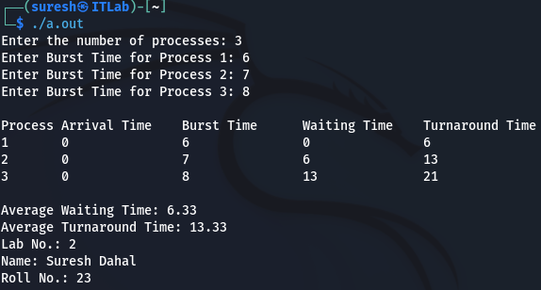

* 1. **WAP in C to simulate SJF CPU Scheduling Algorithm**

**Program**

#include <stdio.h>

void findWaitingTime(int processes[], int n, int bt[], int wt[]) {

wt[0] = 0; // Waiting time for the first process is 0

for (int i = 1; i < n; i++) {

wt[i] = bt[i - 1] + wt[i - 1]; // Waiting time for other processes

}

}

void findTurnAroundTime(int processes[], int n, int bt[], int wt[], int tat[]) {

for (int i = 0; i < n; i++) {

tat[i] = bt[i] + wt[i]; // Turnaround time = Burst time + Waiting time

}

}

void findAverageTime(int processes[], int n, int bt[]) {

int wt[n], tat[n];

findWaitingTime(processes, n, bt, wt); // Calculate waiting time

findTurnAroundTime(processes, n, bt, wt, tat); // Calculate turnaround time

float total_wt = 0, total_tat = 0;

printf("\nProcess\tBurst Time\tWaiting Time\tTurnaround Time\n");

for (int i = 0; i < n; i++) {

total_wt += wt[i];

total_tat += tat[i];

printf("%d\t%d\t\t%d\t\t%d\n", processes[i], bt[i], wt[i], tat[i]);

}

printf("\nAverage Waiting Time: %.2f", total_wt / n);

printf("\nAverage Turnaround Time: %.2f", total_tat / n);

}

// Function to sort processes according to burst time (SJF)

void sortByBurstTime(int processes[], int n, int bt[]) {

for (int i = 0; i < n - 1; i++) {

for (int j = i + 1; j < n; j++) {

if (bt[i] > bt[j]) {

// Swap burst times

int temp = bt[i];

bt[i] = bt[j];

bt[j] = temp;

// Swap corresponding processes

temp = processes[i];

processes[i] = processes[j];

processes[j] = temp;

}

}

}

}

int main() {

int n;

printf("Enter the number of processes: ");

scanf("%d", &n);

int processes[n], burst_time[n];

for (int i = 0; i < n; i++) {

processes[i] = i + 1;

printf("Enter Burst Time for Process %d: ", i + 1);

scanf("%d", &burst_time[i]);

}

sortByBurstTime(processes, n, burst_time); // Sort processes by burst time

findAverageTime(processes, n, burst_time); // Calculate and display average times

printf("\nLab No.: 2\n");

printf("Name: Suresh Dahal\n");

printf("Roll No.: 23\n");

return 0;

}

**Output**

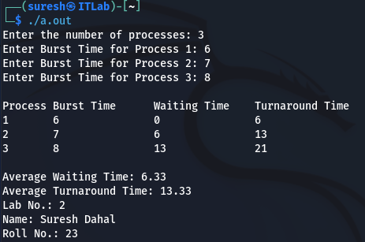

* 1. **WAP in C to simulate SRTF CPU Scheduling Algorithm**

**Program**

#include <stdio.h>

void findWaitingTime(int processes[], int n, int bt[], int at[], int wt[]) {

int remaining_bt[n], completed = 0, current_time = 0, min_time, shortest, i;

for (i = 0; i < n; i++) {

remaining_bt[i] = bt[i];

}

while (completed < n) {

min_time = 999999; // Arbitrarily large number for comparison

shortest = -1;

for (i = 0; i < n; i++) {

if (at[i] <= current_time && remaining_bt[i] < min_time && remaining_bt[i] > 0) {

min_time = remaining_bt[i];

shortest = i;

}

}

if (shortest != -1) {

remaining_bt[shortest]--;

current_time++;

if (remaining_bt[shortest] == 0) {

completed++;

wt[shortest] = current_time - at[shortest] - bt[shortest];

}

} else {

current_time++;

}

}

}

void findTurnAroundTime(int processes[], int n, int bt[], int wt[], int tat[]) {

for (int i = 0; i < n; i++) {

tat[i] = bt[i] + wt[i];

}

}

void findAverageTime(int processes[], int n, int bt[], int at[]) {

int wt[n], tat[n];

findWaitingTime(processes, n, bt, at, wt);

findTurnAroundTime(processes, n, bt, wt, tat);

float total_wt = 0, total_tat = 0;

printf("\nProcess\tArrival Time\tBurst Time\tWaiting Time\tTurnaround Time\n");

for (int i = 0; i < n; i++) {

total_wt += wt[i];

total_tat += tat[i];

printf("%d\t%d\t\t%d\t\t%d\t\t%d\n", processes[i], at[i], bt[i], wt[i], tat[i]);

}

printf("\nAverage Waiting Time: %.2f", total_wt / n);

printf("\nAverage Turnaround Time: %.2f", total_tat / n);

}

int main() {

int n;

printf("Enter the number of processes: ");

scanf("%d", &n);

int processes[n], burst_time[n], arrival_time[n];

for (int i = 0; i < n; i++) {

processes[i] = i + 1;

printf("Enter Arrival Time for Process %d: ", i + 1);

scanf("%d", &arrival_time[i]);

printf("Enter Burst Time for Process %d: ", i + 1);

scanf("%d", &burst_time[i]);

}

findAverageTime(processes, n, burst_time, arrival_time); // Calculate and display average times

printf("\nLab No.: 2\n");

printf("Name: Suresh Dahal\n");

printf("Roll No.: 23\n");

return 0;

}

**Output**

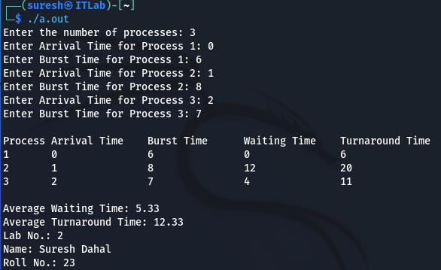

* 1. **WAP in C to simulate Round Robin CPU Scheduling Algorithm**

**Program**

#include <stdio.h>

void findWaitingTime(int processes[], int n, int bt[], int at[], int wt[], int quantum) {

int rem_bt[n], completed = 0, current_time = 0;

for (int i = 0; i < n; i++) {

rem_bt[i] = bt[i];

}

while (completed < n) {

for (int i = 0; i < n; i++) {

if (rem_bt[i] > 0) {

if (rem_bt[i] > quantum) {

rem_bt[i] -= quantum;

current_time += quantum;

} else {

current_time += rem_bt[i];

wt[i] = current_time - at[i] - bt[i];

rem_bt[i] = 0;

completed++;

}

}

}

}

}

void findTurnAroundTime(int processes[], int n, int bt[], int wt[], int tat[]) {

for (int i = 0; i < n; i++) {

tat[i] = bt[i] + wt[i];

}

}

void findAverageTime(int processes[], int n, int bt[], int at[], int quantum) {

int wt[n], tat[n];

findWaitingTime(processes, n, bt, at, wt, quantum); // Calculate waiting time

findTurnAroundTime(processes, n, bt, wt, tat); // Calculate turnaround time

float total_wt = 0, total_tat = 0;

printf("\nProcess\tArrival Time\tBurst Time\tWaiting Time\tTurnaround Time\n");

for (int i = 0; i < n; i++) {

total_wt += wt[i];

total_tat += tat[i];

printf("%d\t%d\t\t%d\t\t%d\t\t%d\n", processes[i], at[i], bt[i], wt[i], tat[i]);

}

printf("\nAverage Waiting Time: %.2f", total_wt / n);

printf("\nAverage Turnaround Time: %.2f", total_tat / n);

}

int main() {

int n, quantum;

printf("Enter the number of processes: ");

scanf("%d", &n);

int processes[n], burst_time[n], arrival_time[n];

for (int i = 0; i < n; i++) {

processes[i] = i + 1;

printf("Enter Arrival Time for Process %d: ", i + 1);

scanf("%d", &arrival_time[i]);

printf("Enter Burst Time for Process %d: ", i + 1);

scanf("%d", &burst_time[i]);

}

printf("Enter Time Quantum: ");

scanf("%d", &quantum);

findAverageTime(processes, n, burst_time, arrival_time, quantum); // Calculate and display average times

printf("\nLab No.: 2\n");

printf("Name: Suresh Dahal\n");

printf("Roll No.: 23\n");

return 0;

}

**Output**

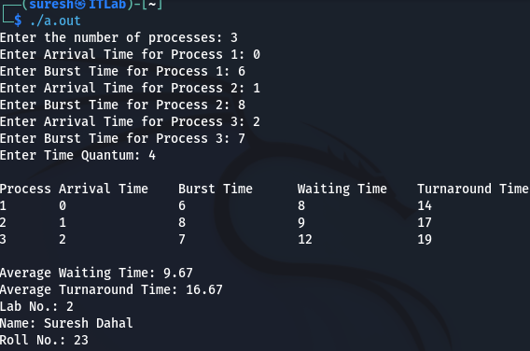

* 1. **WAP in C to simulate Non-Preemptive Priority Scheduling Algorithm**

**Program**

#include <stdio.h>

void findWaitingTime(int processes[], int n, int bt[], int at[], int wt[], int priority[]) {

int completed = 0, current_time = 0;

int remaining = n;

int finish_time[n], remaining_bt[n];

int is_completed[n]; // To track whether a process is completed

for (int i = 0; i < n; i++) {

remaining_bt[i] = bt[i];

is_completed[i] = 0;

}

while (remaining > 0) {

int min_priority = 99999;

int idx = -1;

for (int i = 0; i < n; i++) {

// Find the process with the minimum priority that is ready and not yet completed

if (at[i] <= current_time && is_completed[i] == 0 && priority[i] < min_priority) {

min_priority = priority[i];

idx = i;

}

}

if (idx != -1) {

is_completed[idx] = 1; // Mark process as completed

finish_time[idx] = current_time + bt[idx];

current_time += bt[idx];

remaining--;

} else {

current_time++; // Increment time if no process is ready

}

}

// Calculate waiting time

for (int i = 0; i < n; i++) {

wt[i] = finish_time[i] - at[i] - bt[i];

}

}

void findTurnAroundTime(int processes[], int n, int bt[], int wt[], int tat[]) {

for (int i = 0; i < n; i++) {

tat[i] = bt[i] + wt[i];

}

}

void findAverageTime(int processes[], int n, int bt[], int at[], int priority[]) {

int wt[n], tat[n];

findWaitingTime(processes, n, bt, at, wt, priority); // Calculate waiting time

findTurnAroundTime(processes, n, bt, wt, tat); // Calculate turnaround time

float total_wt = 0, total_tat = 0;

printf("\nProcess\tArrival Time\tBurst Time\tPriority\tWaiting Time\tTurnaround Time\n");

for (int i = 0; i < n; i++) {

total_wt += wt[i];

total_tat += tat[i];

printf("%d\t%d\t\t%d\t\t%d\t\t%d\t\t%d\n", processes[i], at[i], bt[i], priority[i], wt[i], tat[i]);

}

printf("\nAverage Waiting Time: %.2f", total_wt / n);

printf("\nAverage Turnaround Time: %.2f", total_tat / n);

}

int main() {

int n;

printf("Enter the number of processes: ");

scanf("%d", &n);

int processes[n], burst_time[n], arrival_time[n], priority[n];

for (int i = 0; i < n; i++) {

processes[i] = i + 1;

printf("Enter Arrival Time for Process %d: ", i + 1);

scanf("%d", &arrival_time[i]);

printf("Enter Burst Time for Process %d: ", i + 1);

scanf("%d", &burst_time[i]);

printf("Enter Priority for Process %d: ", i + 1);

scanf("%d", &priority[i]);

}

findAverageTime(processes, n, burst_time, arrival_time, priority); // Calculate and display average times

printf("\nLab No.: 2\n");

printf("Name: Suresh Dahal\n");

printf("Roll No.: 23\n");

return 0;

}

**Output**

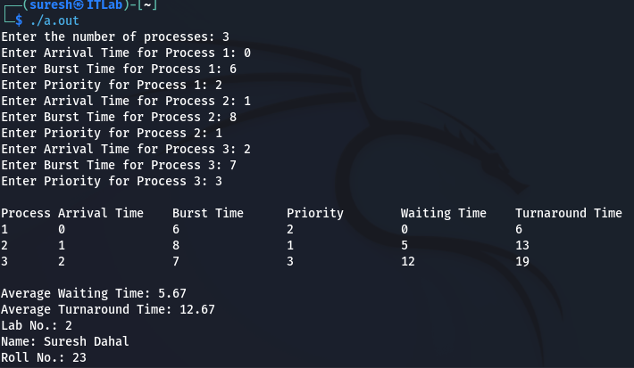

* 1. **WAP in C to simulate Preemptive Priority Scheduling Algorithm**

**Program**

#include <stdio.h>

void findWaitingTime(int processes[], int n, int bt[], int at[], int wt[], int priority[]) {

int remaining = n;

int remaining_bt[n];

int finish_time[n];

int is_completed[n];

int current_time = 0;

int min_priority, idx;

for (int i = 0; i < n; i++) {

remaining_bt[i] = bt[i];

is_completed[i] = 0;

}

while (remaining > 0) {

min_priority = 9999;

idx = -1;

for (int i = 0; i < n; i++) {

if (at[i] <= current_time && is_completed[i] == 0 && priority[i] < min_priority) {

min_priority = priority[i];

idx = i;

}

}

if (idx != -1) {

remaining_bt[idx]--;

if (remaining_bt[idx] == 0) {

is_completed[idx] = 1;

remaining--;

finish_time[idx] = current_time + 1;

}

current_time++;

} else {

current_time++; // Increment time if no process is ready

}

}

// Calculate waiting time

for (int i = 0; i < n; i++) {

wt[i] = finish_time[i] - at[i] - bt[i];

}

}

void findTurnAroundTime(int processes[], int n, int bt[], int wt[], int tat[]) {

for (int i = 0; i < n; i++) {

tat[i] = bt[i] + wt[i];

}

}

void findAverageTime(int processes[], int n, int bt[], int at[], int priority[]) {

int wt[n], tat[n];

findWaitingTime(processes, n, bt, at, wt, priority); // Calculate waiting time

findTurnAroundTime(processes, n, bt, wt, tat); // Calculate turnaround time

float total_wt = 0, total_tat = 0;

printf("\nProcess\tArrival Time\tBurst Time\tPriority\tWaiting Time\tTurnaround Time\n");

for (int i = 0; i < n; i++) {

total_wt += wt[i];

total_tat += tat[i];

printf("%d\t%d\t\t%d\t\t%d\t\t%d\t\t%d\n", processes[i], at[i], bt[i], priority[i], wt[i], tat[i]);

}

printf("\nAverage Waiting Time: %.2f", total_wt / n);

printf("\nAverage Turnaround Time: %.2f", total_tat / n);

}

int main() {

int n;

printf("Enter the number of processes: ");

scanf("%d", &n);

int processes[n], burst_time[n], arrival_time[n], priority[n];

for (int i = 0; i < n; i++) {

processes[i] = i + 1;

printf("Enter Arrival Time for Process %d: ", i + 1);

scanf("%d", &arrival_time[i]);

printf("Enter Burst Time for Process %d: ", i + 1);

scanf("%d", &burst_time[i]);

printf("Enter Priority for Process %d: ", i + 1);

scanf("%d", &priority[i]);

}

findAverageTime(processes, n, burst_time, arrival_time, priority); // Calculate and display average times

printf("\nLab No.: 2\n");

printf("Name: Suresh Dahal\n");

printf("Roll No.: 23\n");

return 0;

}

**Output**

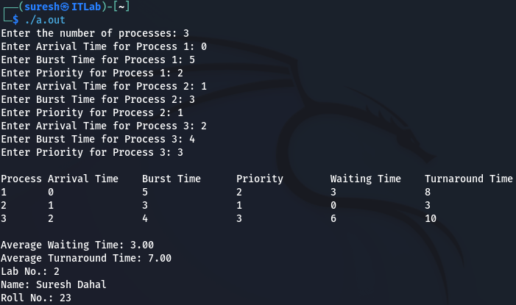

**TITLE: Simulation of Deadlock Avoidance and Deadlock Detection Algorithms**

**THEORY**

Deadlock avoidance ensures that resources are allocated in a way that avoids deadlock, often using techniques like the Banker's Algorithm. Deadlock detection periodically checks if a deadlock has occurred and takes corrective actions, such as terminating processes or rolling back operations.

1. **WAP to implement Bankers Algorithm for multiple type of resources to decide safe/unsafe state.**

**Program**

#include <stdio.h>

#include <stdbool.h>

#define MAX 10

#define RESOURCE_TYPES 3

Void calculateNeed(int need[MAX][RESOURCE_TYPES], int max[MAX][RESOURCE_TYPES], int allocation[MAX][RESOURCE_TYPES], int n) {

for (int i = 0; i < n; i++) {

for (int j = 0; j < RESOURCE_TYPES; j++) {

need[i][j] = max[i][j] - allocation[i][j];

}

}

}

bool isLessThanOrEqual(int need[], int work[], int m) {

for (int i = 0; i < m; i++) {

if (need[i] > work[i]) {

return false;

}

}

return true;

}

void bankersAlgorithm(int allocation[MAX][RESOURCE_TYPES], int max[MAX][RESOURCE_TYPES], int available[], int n) {

int need[MAX][RESOURCE_TYPES];

int work[RESOURCE_TYPES];

bool finish[MAX];

int safeSeq[MAX];

int count = 0;

// Calculate the Need matrix

calculateNeed(need, max, allocation, n);

for (int i = 0; i < n; i++) {

finish[i] = false;

}

for (int i = 0; i < RESOURCE_TYPES; i++) {

work[i] = available[i];

}

// Start checking for safe sequence

while (count < n) {

bool progressMade = false;

for (int i = 0; i < n; i++) {

// Find a process that has not finished and can proceed

if (!finish[i] && isLessThanOrEqual(need[i], work, RESOURCE_TYPES)) {

// If it can proceed, pretend it finishes and release resources

for (int j = 0; j < RESOURCE_TYPES; j++) {

work[j] += allocation[i][j];

}

safeSeq[count++] = i;

finish[i] = true;

progressMade = true;

break;

}

}

if (!progressMade) {

// No process could proceed, unsafe state

printf("Unsafe state\n");

return;

}

}

// If all processes finished

printf("Safe state\nSafe sequence: ");

for (int i = 0; i < n; i++) {

printf("P%d ", safeSeq[i]);

}

printf("\n");

}

int main() {

int n, m;

// Take number of processes and resources

printf("Enter number of processes: ");

scanf("%d", &n);

printf("Enter number of resource types: ");

scanf("%d", &m);

int allocation[MAX][RESOURCE_TYPES], max[MAX][RESOURCE_TYPES], available[RESOURCE_TYPES];

// Input allocation matrix

printf("Enter the allocation matrix (currently allocated resources):\n");

for (int i = 0; i < n; i++) {

printf("Process P%d: ", i);

for (int j = 0; j < m; j++) {

scanf("%d", &allocation[i][j]);

}

}

// Input max matrix

printf("Enter the maximum matrix (maximum resources needed):\n");

for (int i = 0; i < n; i++) {

printf("Process P%d: ", i);

for (int j = 0; j < m; j++) {

scanf("%d", &max[i][j]);

}

}

// Input available resources

printf("Enter available resources:\n");

for (int i = 0; i < m; i++) {

scanf("%d", &available[i]);

}

// Run Banker's Algorithm

bankersAlgorithm(allocation, max, available, n);

// Print lab info at the end

printf("\nLab No: 2\nName: Suresh Dahal\nRoll No: 23\n");

return 0;

}

**Output**

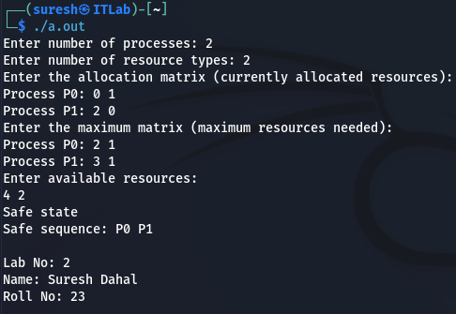

Figure 1 Safe state

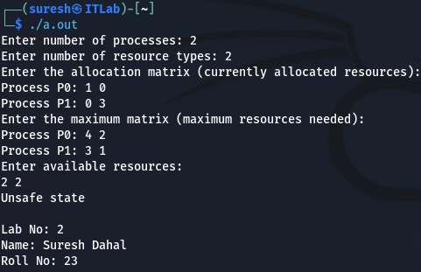

Figure 2 unsafe state

1. **WAP for deadlock detection in the system having multiple type of resources. The program should list the deadlocked process in case of deadlock detection results true.**

**Program**

#include <stdio.h>

#include <stdbool.h>

#define MAX_PROCESSES 10

#define MAX_RESOURCES 10

int processes, resources;

int allocation[MAX_PROCESSES][MAX_RESOURCES];

int maximum[MAX_PROCESSES][MAX_RESOURCES];

int available[MAX_RESOURCES];

int need[MAX_PROCESSES][MAX_RESOURCES];

void findDeadlocks() {

int work[MAX_RESOURCES];

bool finish[MAX_PROCESSES] = {0};

int deadlock[MAX_PROCESSES];

int deadlockCount = 0;

// Initialize work with available resources

for (int i = 0; i < resources; i++) {

work[i] = available[i];

}

while (1) {

bool progressMade = false;

// Try to find a process that can complete

for (int p = 0; p < processes; p++) {

if (!finish[p]) {

bool canProceed = true;

// Check if the process can proceed with available resources

for (int r = 0; r < resources; r++) {

if (need[p][r] > work[r]) {

canProceed = false;

break;

}

}

if (canProceed) {

// If the process can proceed, add its allocated resources to work

for (int r = 0; r < resources; r++) {

work[r] += allocation[p][r];

}

finish[p] = true;

progressMade = true;

break;

}

}

}

if (!progressMade) {

// If no progress can be made, we have found deadlocked processes

for (int i = 0; i < processes; i++) {

if (!finish[i]) {

deadlock[deadlockCount++] = i;

}

}

break;

}

}

if (deadlockCount > 0) {

printf("Deadlocked processes: ");

for (int i = 0; i < deadlockCount; i++) {

printf("P%d ", deadlock[i]);

}

printf("\n");

} else {

printf("No deadlock detected.\n");

}

}

int main() {

printf("Enter the number of processes: ");

scanf("%d", &processes);

printf("Enter the number of resources: ");

scanf("%d", &resources);

// Input the allocation matrix

printf("Enter the allocation matrix:\n");

for (int i = 0; i < processes; i++) {

printf("Process P%d: ", i);

for (int j = 0; j < resources; j++) {

scanf("%d", &allocation[i][j]);

}

}

// Input the maximum matrix

printf("Enter the maximum matrix:\n");

for (int i = 0; i < processes; i++) {

printf("Process P%d: ", i);

for (int j = 0; j < resources; j++) {

scanf("%d", &maximum[i][j]);

}

}

// Calculate the need matrix

for (int i = 0; i < processes; i++) {

for (int j = 0; j < resources; j++) {

need[i][j] = maximum[i][j] - allocation[i][j];

}

}

// Input the available resources

printf("Enter available resources:\n");

for (int i = 0; i < resources; i++) {

scanf("%d", &available[i]);

}

// Call the deadlock detection function

findDeadlocks();

printf(“Lab no.: 2\nName: Suresh Dahal\nRoll no.: 23”);

return 0;

}

**Output**

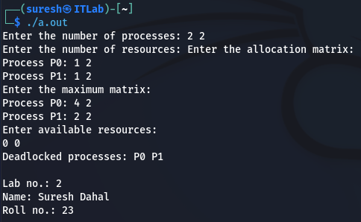

**TITLE: Simulation of Page Replacement Algorithms**

**THEORY**

Page replacement algorithms decide which pages to keep in memory and which to swap out during a page fault. Common algorithms include FIFO, Optimal, LRU, Second Chance, and LFU. Each algorithm aims to minimize page faults and optimize memory usage.

1. **WAP in C to simulate FIFO Page Replacement Algorithm**

**Program**

#include <stdio.h>

void FIFO(int frameCount, int referenceString[], int size) {

int frames[frameCount];

int pageFaults = 0;

int index = 0;

int isPageInMemory;

for (int i = 0; i < frameCount; i++) {

frames[i] = -1;

}

printf("Reference String: ");

for (int i = 0; i < size; i++) {

printf("%d ", referenceString[i]);

}

printf("\n");

for (int i = 0; i < size; i++) {

isPageInMemory = 0;

// Check if the page is already in memory

for (int j = 0; j < frameCount; j++) {

if (frames[j] == referenceString[i]) {

isPageInMemory = 1;

break;

}

}

// If page is not in memory, replace the oldest page (FIFO)

if (!isPageInMemory) {

frames[index] = referenceString[i];

index = (index + 1) % frameCount;

pageFaults++;

printf("Page %d caused a page fault. Frames: ", referenceString[i]);

for (int j = 0; j < frameCount; j++) {

printf("%d ", frames[j]);

}

printf("\n");

}

}

printf("\nTotal Page Faults: %d\n", pageFaults);

printf("Lab No.: 2\n");

printf("Name: Suresh Dahal\n");

printf("Roll No.: 23\n");

}

int main() {

int frameCount, size;

printf("Enter number of frames: ");

scanf("%d", &frameCount);

printf("Enter size of reference string: ");

scanf("%d", &size);

int referenceString[size];

printf("Enter the reference string: ");

for (int i = 0; i < size; i++) {

scanf("%d", &referenceString[i]);

}

FIFO(frameCount, referenceString, size);

return 0;

}

**Output**

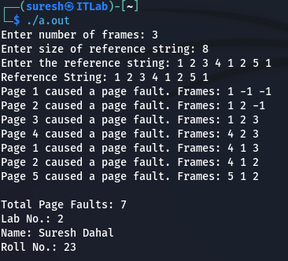

1. **WAP in C to simulate Optimal Page Replacement Algorithm**

**Program**

#include <stdio.h>

#define MAX_PAGES 10

#define MAX_FRAMES 10

int frames[MAX_FRAMES];

int referenceString[MAX_PAGES];

int findOptimalPageToReplace(int currentIndex, int frames[], int referenceString[], int n) {

int farthest = currentIndex;

int pageToReplace = -1;

for (int i = 0; i < n; i++) {

int page = frames[i];

int j;

for (j = currentIndex; j < n; j++) {

if (referenceString[j] == page) {

break;

}

}

if (j == n) {

return i; // If the page is not found, replace it

}

if (j > farthest) {

farthest = j;

pageToReplace = i;

}

}

return pageToReplace;

}

int main() {

int numPages, numFrames;

printf("Enter the number of pages: ");

scanf("%d", &numPages);

printf("Enter the reference string (sequence of page numbers):\n");

for (int i = 0; i < numPages; i++) {

scanf("%d", &referenceString[i]);

}

printf("Enter the number of frames: ");

scanf("%d", &numFrames);

// Initialize frames with -1 (empty slots)

for (int i = 0; i < numFrames; i++) {

frames[i] = -1;

}

int pageFaults = 0;

// Simulate the optimal page replacement algorithm

for (int i = 0; i < numPages; i++) {

int page = referenceString[i];

int pageFound = 0;

// Check if page is already in one of the frames

for (int j = 0; j < numFrames; j++) {

if (frames[j] == page) {

pageFound = 1;

break;

}

}

// If page is not found, it's a page fault

if (!pageFound) {

pageFaults++;

int pageToReplace = findOptimalPageToReplace(i + 1, frames, referenceString, numPages);

// Replace the page

frames[pageToReplace] = page;

// Print the current frames

printf("Current frames: ");

for (int j = 0; j < numFrames; j++) {

printf("%d ", frames[j]);

}

printf("\n");

}

}

printf("\nTotal page faults: %d\n", pageFaults);

printf("Lab No: 2\n");

printf("Name: Suresh Dahal\n");

printf("Roll No: 23\n");

return 0;

}

**Output**

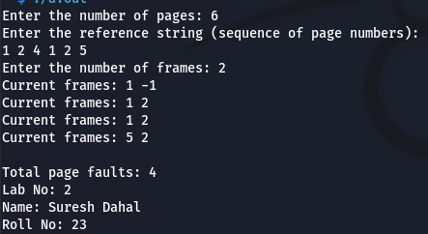

1. **WAP in C to simulate LRU Page Replacement Algorithm**

**Program**

#include <stdio.h>

#define MAX_PAGES 10

#define MAX_FRAMES 10

int frames[MAX_FRAMES];

int referenceString[MAX_PAGES];

int isPageInFrames(int page, int frames[], int numFrames) {

for (int i = 0; i < numFrames; i++) {

if (frames[i] == page) {

return 1; // Page is in frames

}

}

return 0; // Page is not in frames

}

int getLRUPage(int numFrames, int frames[], int recent[], int numPages, int currentIndex) {

int lruIndex = 0;

for (int i = 1; i < numFrames; i++) {

if (recent[frames[i]] < recent[frames[lruIndex]]) {

lruIndex = i;

}

}

return lruIndex;

}

int main() {

int numPages, numFrames;

printf("Enter the number of pages: ");

scanf("%d", &numPages);

printf("Enter the reference string (sequence of page numbers):\n");

for (int i = 0; i < numPages; i++) {

scanf("%d", &referenceString[i]);

}

printf("Enter the number of frames: ");

scanf("%d", &numFrames);

// Initialize frames with -1 (empty slots)

for (int i = 0; i < numFrames; i++) {

frames[i] = -1;

}

// Array to keep track of last usage time of pages

int recent[MAX_PAGES] = {0};

int pageFaults = 0;

// Simulate the LRU page replacement algorithm

for (int i = 0; i < numPages; i++) {

int page = referenceString[i];

int pageFound = 0;

// Check if page is already in one of the frames

if (isPageInFrames(page, frames, numFrames)) {

pageFound = 1;

}

// If page is not found, it's a page fault

if (!pageFound) {

pageFaults++;

int replaceIndex = getLRUPage(numFrames, frames, recent, numPages, i);

// Replace the LRU page

frames[replaceIndex] = page;

}

// Update the recent usage time of the page

recent[page] = i;

// Print the current frames after each page fault

printf("Current frames: ");

for (int j = 0; j < numFrames; j++) {

printf("%d ", frames[j]);

}

printf("\n");

}

printf("\nTotal page faults: %d\n", pageFaults);

printf("Lab No: 2\n");

printf("Name: Suresh Dahal\n");

printf("Roll No: 23\n");

return 0;

}

**Output**

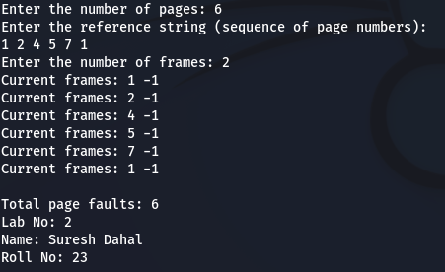

1. **WAP in C to simulate Second Chance Page Replacement Algorithm**

**Program**

#include <stdio.h>

#define MAX_PAGES 10

#define MAX_FRAMES 10

int frames[MAX_FRAMES];

int referenceString[MAX_PAGES];

int main() {

int numPages, numFrames;

int referenceBits[MAX_FRAMES] = {0}; // To track reference bits (0 or 1)

printf("Enter the number of pages: ");

scanf("%d", &numPages);

printf("Enter the reference string (sequence of page numbers):\n");

for (int i = 0; i < numPages; i++) {

scanf("%d", &referenceString[i]);

}

printf("Enter the number of frames: ");

scanf("%d", &numFrames);

// Initialize frames with -1 (empty slots)

for (int i = 0; i < numFrames; i++) {

frames[i] = -1;

}

int pageFaults = 0;

int pointer = 0; // To keep track of the next frame to replace

// Simulate the Second Chance page replacement algorithm

for (int i = 0; i < numPages; i++) {

int page = referenceString[i];

int pageFound = 0;

// Check if page is already in one of the frames

for (int j = 0; j < numFrames; j++) {

if (frames[j] == page) {

pageFound = 1; // Page hit

referenceBits[j] = 1; // Set reference bit

break;

}

}

// If page is not found, it's a page fault

if (!pageFound) {

pageFaults++;

// Find an empty slot or a page to replace using the second chance mechanism

while (referenceBits[pointer] == 1) {

referenceBits[pointer] = 0; // Reset the reference bit to 0

pointer = (pointer + 1) % numFrames; // Move the pointer to the next frame

}

// Replace the page

frames[pointer] = page;

referenceBits[pointer] = 1; // Set reference bit to 1 for the newly loaded page

pointer = (pointer + 1) % numFrames; // Move the pointer to the next frame

}

// Print the current frames after each page fault

printf("Current frames: ");

for (int j = 0; j < numFrames; j++) {

printf("%d ", frames[j]);

}

printf("\n");

}

printf("\nTotal page faults: %d\n", pageFaults);

printf("Lab No: 2\n");

printf("Name: Suresh Dahal\n");

printf("Roll No: 23\n");

return 0;

}

**Output**

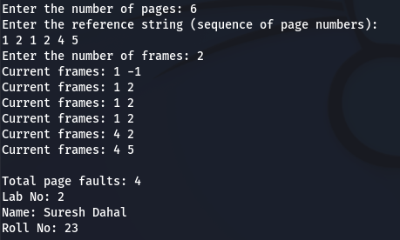

1. **WAP in C to simulate LFU Page Replacement Algorithm**

**Program**

#include <stdio.h>

#define MAX_PAGES 10

#define MAX_FRAMES 10

int frames[MAX_FRAMES];

int referenceString[MAX_PAGES];

int main() {

int numPages, numFrames;

int frequency[MAX_FRAMES]; // To track the frequency of page accesses

int pageFaults = 0;

printf("Enter the number of pages: ");

scanf("%d", &numPages);

printf("Enter the reference string (sequence of page numbers):\n");

for (int i = 0; i < numPages; i++) {

scanf("%d", &referenceString[i]);

}

printf("Enter the number of frames: ");

scanf("%d", &numFrames);

// Initialize frames with -1 (empty slots) and frequency to 0

for (int i = 0; i < numFrames; i++) {

frames[i] = -1;

frequency[i] = 0;

}

// Simulate LFU page replacement algorithm

for (int i = 0; i < numPages; i++) {

int page = referenceString[i];

int pageFound = 0;

// Check if the page is already in one of the frames

for (int j = 0; j < numFrames; j++) {

if (frames[j] == page) {

pageFound = 1; // Page hit

frequency[j]++; // Increment frequency of the page

break;

}

}

// If page is not found, it's a page fault

if (!pageFound) {

pageFaults++;

// Find the least frequently used page to replace

int minFrequency = frequency[0];

int minIndex = 0;

// Find the frame with the least frequency

for (int j = 1; j < numFrames; j++) {

if (frequency[j] < minFrequency) {

minFrequency = frequency[j];

minIndex = j;

}

}

// Replace the least frequently used page

frames[minIndex] = page;

frequency[minIndex] = 1; // Reset frequency of the newly loaded page

}

// Print the current frames after each page fault

printf("Current frames: ");

for (int j = 0; j < numFrames; j++) {

printf("%d ", frames[j]);

}

printf("\n");

}

printf("\nTotal page faults: %d\n", pageFaults);

printf("Lab No: 2\n");

printf("Name: Suresh Dahal\n");

printf("Roll No: 23\n");

return 0;

}

**Output**

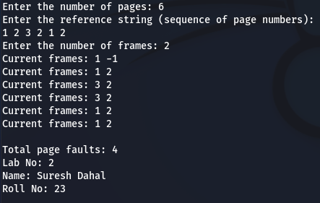

**TITLE: Simulation of disk scheduling algorithms**

**THEORY**

Disk scheduling algorithms manage the order of disk I/O requests to minimize seek time and improve efficiency. Common algorithms include **FCFS**, **SSTF**, **SCAN**, **C-SCAN**, and **LOOK**, each optimizing disk access in different ways based on request patterns.

1. **WAP to simulate FCFS Disk Scheduling Algorithm**

**Program**

#include <stdio.h>

#include <stdlib.h>

#define MAX_REQUESTS 100

// Function to calculate the total seek time

int calculateSeekTime(int requests[], int numRequests, int start) {

int seekTime = 0;

int current = start;

for (int i = 0; i < numRequests; i++) {

seekTime += abs(current - requests[i]);

current = requests[i];

}

return seekTime;

}

int main() {

int numRequests, start, seekTime;

// Input the number of requests

printf("Enter the number of disk access requests: ");

scanf("%d", &numRequests);

int requests[numRequests];

// Input the disk access requests

printf("Enter the disk access requests (disk block numbers):\n");

for (int i = 0; i < numRequests; i++) {

scanf("%d", &requests[i]);

}

// Input the starting position of the disk arm

printf("Enter the starting position of the disk arm: ");

scanf("%d", &start);

// Calculate the total seek time for FCFS

seekTime = calculateSeekTime(requests, numRequests, start);

// Display the result

printf("\nDisk Access Requests: ");

for (int i = 0; i < numRequests; i++) {

printf("%d ", requests[i]);

}

printf("\nTotal Seek Time = %d\n", seekTime);

// Printing lab details

printf("\nLab No.: 2\n");

printf("Name: Suresh Dahal\n");

printf("Roll No.: 23\n");

return 0;

}

**Output**

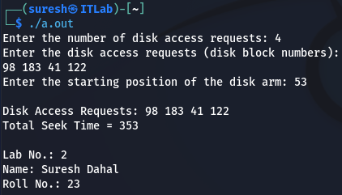

1. **WAP to simulate SSTF Disk Scheduling Algorithm**

**Program**

#include <stdio.h>

#include <stdlib.h>

#define MAX_REQUESTS 100

// Function to calculate the total seek time

int calculateSeekTime(int requests[], int numRequests, int start) {

int seekTime = 0;

int current = start;

int completed[numRequests];

for (int i = 0; i < numRequests; i++) {

completed[i] = 0; // Initialize the completed array to 0 (not completed)

}

int remaining = numRequests;

while (remaining > 0) {

int minDistance = 999999; // Set a large value for the minimum distance

int closestRequest = -1;

// Find the closest request to the current position

for (int i = 0; i < numRequests; i++) {

if (!completed[i]) {

int distance = abs(current - requests[i]);

if (distance < minDistance) {

minDistance = distance;

closestRequest = i;

}

}

}

// Update the seek time and the current position

seekTime += minDistance;

current = requests[closestRequest];

completed[closestRequest] = 1; // Mark the request as completed

remaining--; // Decrease the remaining requests count

}

return seekTime;

}

int main() {

int numRequests, start, seekTime;

// Input the number of requests

printf("Enter the number of disk access requests: ");

scanf("%d", &numRequests);

int requests[numRequests];

// Input the disk access requests

printf("Enter the disk access requests (disk block numbers):\n");

for (int i = 0; i < numRequests; i++) {

scanf("%d", &requests[i]);

}

// Input the starting position of the disk arm

printf("Enter the starting position of the disk arm: ");

scanf("%d", &start);

// Calculate the total seek time for SSTF

seekTime = calculateSeekTime(requests, numRequests, start);

// Display the result

printf("\nDisk Access Requests: ");

for (int i = 0; i < numRequests; i++) {

printf("%d ", requests[i]);

}

printf("\nTotal Seek Time = %d\n", seekTime);

// Printing lab details

printf("\nLab No.: 2\n");

printf("Name: Suresh Dahal\n");

printf("Roll No.: 23\n");

return 0;

}

**Output**

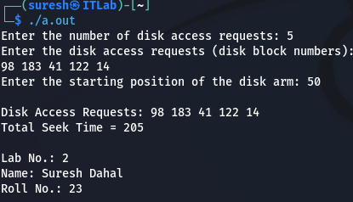

1. **WAP to simulate SCAN Disk Scheduling Algorithm**

**Program**

#include <stdio.h>

#include <stdlib.h>

#define MAX_REQUESTS 100

// Function to calculate the total seek time

int calculateSeekTime(int requests[], int numRequests, int start, int diskSize, int direction) {

int seekTime = 0;

int current = start;

// Sort the requests to process them in order

int sortedRequests[numRequests];

for (int i = 0; i < numRequests; i++) {

sortedRequests[i] = requests[i];

}

// Sort the requests in ascending order

for (int i = 0; i < numRequests - 1; i++) {

for (int j = 0; j < numRequests - i - 1; j++) {

if (sortedRequests[j] > sortedRequests[j + 1]) {

int temp = sortedRequests[j];

sortedRequests[j] = sortedRequests[j + 1];

sortedRequests[j + 1] = temp;

}

}

}

// Calculate the seek time

if (direction == 1) {

// Moving to the right (ascending order)

for (int i = 0; i < numRequests; i++) {

if (sortedRequests[i] >= current) {

seekTime += abs(current - sortedRequests[i]);

current = sortedRequests[i];

}

}

// Reverse direction

seekTime += abs(current - (diskSize - 1));

current = diskSize - 1;

for (int i = numRequests - 1; i >= 0; i--) {

if (sortedRequests[i] <= current) {

seekTime += abs(current - sortedRequests[i]);

current = sortedRequests[i];

}

}

} else {

// Moving to the left (descending order)

for (int i = numRequests - 1; i >= 0; i--) {

if (sortedRequests[i] <= current) {

seekTime += abs(current - sortedRequests[i]);

current = sortedRequests[i];

}

}

// Reverse direction

seekTime += abs(current - 0);

current = 0;

for (int i = 0; i < numRequests; i++) {

if (sortedRequests[i] >= current) {

seekTime += abs(current - sortedRequests[i]);

current = sortedRequests[i];

}

}

}

return seekTime;

}

int main() {

int numRequests, start, diskSize, direction, seekTime;

// Input the number of requests

printf("Enter the number of disk access requests: ");

scanf("%d", &numRequests);

int requests[numRequests];

// Input the disk access requests

printf("Enter the disk access requests (disk block numbers):\n");

for (int i = 0; i < numRequests; i++) {

scanf("%d", &requests[i]);

}

// Input the starting position of the disk arm and disk size

printf("Enter the starting position of the disk arm: ");

scanf("%d", &start);

printf("Enter the total number of disk blocks: ");

scanf("%d", &diskSize);

// Input the direction of the arm (1 for right, 0 for left)

printf("Enter the direction of the disk arm (1 for right, 0 for left): ");

scanf("%d", &direction);

// Calculate the total seek time for SCAN

seekTime = calculateSeekTime(requests, numRequests, start, diskSize, direction);

// Display the result

printf("\nDisk Access Requests: ");

for (int i = 0; i < numRequests; i++) {

printf("%d ", requests[i]);

}

printf("\nTotal Seek Time = %d\n", seekTime);

// Printing lab details

printf("\nLab No.: 2\n");

printf("Name: Suresh Dahal\n");

printf("Roll No.: 23\n");

return 0;

}

**Output**

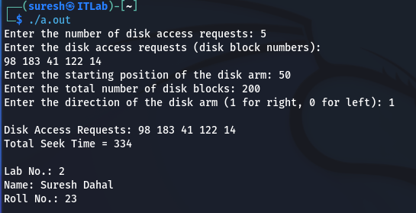

1. **WAP to simulate C-SCAN Disk Scheduling Algorithm**

**Program**

#include <stdio.h>

#include <stdlib.h>

#define MAX_REQUESTS 100

// Function to calculate the total seek time

int calculateSeekTime(int requests[], int numRequests, int start, int diskSize, int direction) {

int seekTime = 0;

int current = start;

// Sort the requests to process them in order

int sortedRequests[numRequests];

for (int i = 0; i < numRequests; i++) {

sortedRequests[i] = requests[i];

}

// Sort the requests in ascending order

for (int i = 0; i < numRequests - 1; i++) {

for (int j = 0; j < numRequests - i - 1; j++) {

if (sortedRequests[j] > sortedRequests[j + 1]) {

int temp = sortedRequests[j];

sortedRequests[j] = sortedRequests[j + 1];

sortedRequests[j + 1] = temp;

}

}

}

// Calculate the seek time for C-SCAN

if (direction == 1) {

// Moving to the right (ascending order)

for (int i = 0; i < numRequests; i++) {

if (sortedRequests[i] >= current) {

seekTime += abs(current - sortedRequests[i]);

current = sortedRequests[i];

}

}

// Move to the end of the disk

seekTime += abs(current - (diskSize - 1));

current = diskSize - 1;

// Jump to the beginning of the disk and service the requests

seekTime += abs(current - 0);

current = 0;

// Continue servicing the requests from the beginning

for (int i = 0; i < numRequests; i++) {

if (sortedRequests[i] >= current) {

seekTime += abs(current - sortedRequests[i]);

current = sortedRequests[i];

}

}

} else {

// Moving to the left (descending order)

for (int i = numRequests - 1; i >= 0; i--) {

if (sortedRequests[i] <= current) {

seekTime += abs(current - sortedRequests[i]);

current = sortedRequests[i];

}

}

// Move to the beginning of the disk

seekTime += abs(current - 0);

current = 0;

// Jump to the end of the disk and service the requests

seekTime += abs(current - (diskSize - 1));

current = diskSize - 1;

// Continue servicing the requests from the end

for (int i = numRequests - 1; i >= 0; i--) {

if (sortedRequests[i] <= current) {

seekTime += abs(current - sortedRequests[i]);

current = sortedRequests[i];

}

}

}

return seekTime;

}

int main() {

int numRequests, start, diskSize, direction, seekTime;

// Input the number of requests

printf("Enter the number of disk access requests: ");

scanf("%d", &numRequests);

int requests[numRequests];

// Input the disk access requests

printf("Enter the disk access requests (disk block numbers):\n");

for (int i = 0; i < numRequests; i++) {

scanf("%d", &requests[i]);

}

// Input the starting position of the disk arm and disk size

printf("Enter the starting position of the disk arm: ");

scanf("%d", &start);

printf("Enter the total number of disk blocks: ");

scanf("%d", &diskSize);

// Input the direction of the arm (1 for right, 0 for left)

printf("Enter the direction of the disk arm (1 for right, 0 for left): ");

scanf("%d", &direction);

// Calculate the total seek time for C-SCAN

seekTime = calculateSeekTime(requests, numRequests, start, diskSize, direction);

// Display the result

printf("\nDisk Access Requests: ");

for (int i = 0; i < numRequests; i++) {

printf("%d ", requests[i]);

}

printf("\nTotal Seek Time = %d\n", seekTime);

// Printing lab details

printf("\nLab No.: 2\n");

printf("Name: Suresh Dahal\n");

printf("Roll No.: 23\n");

return 0;

}

**Output**

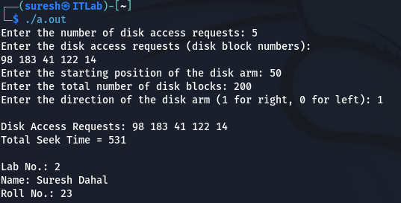

1. **WAP to simulate LOOK Disk Scheduling Algorithm**

**Program**

#include <stdio.h>

#include <stdlib.h>

#define MAX_REQUESTS 100

// Function to calculate the total seek time

int calculateSeekTime(int requests[], int numRequests, int start, int diskSize, int direction) {

int seekTime = 0;

int current = start;

// Sort the requests to process them in order

int sortedRequests[numRequests];

for (int i = 0; i < numRequests; i++) {

sortedRequests[i] = requests[i];

}

// Sort the requests in ascending order

for (int i = 0; i < numRequests - 1; i++) {

for (int j = 0; j < numRequests - i - 1; j++) {

if (sortedRequests[j] > sortedRequests[j + 1]) {

int temp = sortedRequests[j];

sortedRequests[j] = sortedRequests[j + 1];

sortedRequests[j + 1] = temp;

}

}

}

// Calculate the seek time for LOOK

if (direction == 1) {

// Moving to the right (ascending order)

for (int i = 0; i < numRequests; i++) {

if (sortedRequests[i] >= current) {

seekTime += abs(current - sortedRequests[i]);

current = sortedRequests[i];

}

}

// Reverse direction and move to the left

for (int i = numRequests - 1; i >= 0; i--) {

if (sortedRequests[i] < current) {

seekTime += abs(current - sortedRequests[i]);

current = sortedRequests[i];

}

}

} else {

// Moving to the left (descending order)

for (int i = numRequests - 1; i >= 0; i--) {

if (sortedRequests[i] <= current) {

seekTime += abs(current - sortedRequests[i]);

current = sortedRequests[i];

}

}

// Reverse direction and move to the right

for (int i = 0; i < numRequests; i++) {

if (sortedRequests[i] > current) {

seekTime += abs(current - sortedRequests[i]);

current = sortedRequests[i];

}

}

}

return seekTime;

}

int main() {

int numRequests, start, diskSize, direction, seekTime;

// Input the number of requests

printf("Enter the number of disk access requests: ");

scanf("%d", &numRequests);

int requests[numRequests];

// Input the disk access requests

printf("Enter the disk access requests (disk block numbers):\n");

for (int i = 0; i < numRequests; i++) {

scanf("%d", &requests[i]);

}

// Input the starting position of the disk arm and disk size

printf("Enter the starting position of the disk arm: ");

scanf("%d", &start);

printf("Enter the total number of disk blocks: ");

scanf("%d", &diskSize);

// Input the direction of the arm (1 for right, 0 for left)

printf("Enter the direction of the disk arm (1 for right, 0 for left): ");

scanf("%d", &direction);

// Calculate the total seek time for LOOK

seekTime = calculateSeekTime(requests, numRequests, start, diskSize, direction);

// Display the result

printf("\nDisk Access Requests: ");

for (int i = 0; i < numRequests; i++) {

printf("%d ", requests[i]);

}

printf("\nTotal Seek Time = %d\n", seekTime);

// Printing lab details

printf("\nLab No.: 2\n");

printf("Name: Suresh Dahal\n");

printf("Roll No.: 23\n");

return 0;

}

**Output**

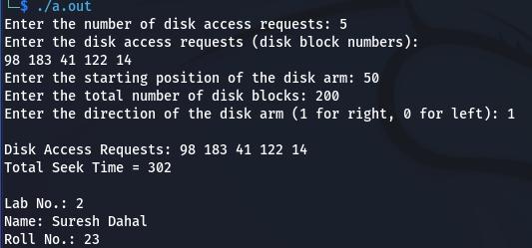

1. **WAP to simulate C-LOOK Disk Scheduling Algorithm**

**Program**

#include <stdio.h>

#include <stdlib.h>

#define MAX_REQUESTS 100

// Function to calculate the total seek time using C-LOOK

int calculateSeekTime(int requests[], int numRequests, int start, int diskSize) {

int seekTime = 0;

int current = start;

// Sort the requests in ascending order

int sortedRequests[numRequests];

for (int i = 0; i < numRequests; i++) {

sortedRequests[i] = requests[i];

}

for (int i = 0; i < numRequests - 1; i++) {

for (int j = 0; j < numRequests - i - 1; j++) {

if (sortedRequests[j] > sortedRequests[j + 1]) {

int temp = sortedRequests[j];

sortedRequests[j] = sortedRequests[j + 1];

sortedRequests[j + 1] = temp;

}

}

}

// Find the total seek time for C-LOOK

int i;

// Move towards the right (ascending order)

for (i = 0; i < numRequests; i++) {

if (sortedRequests[i] >= current) {

break;

}

}

// Travel to the last request in the current direction

for (int j = i; j < numRequests; j++) {

seekTime += abs(current - sortedRequests[j]);

current = sortedRequests[j];

}

// Jump to the first request and travel back in the same direction

seekTime += abs(current - sortedRequests[0]);

current = sortedRequests[0];

// Now travel from the first to the last request in ascending order

for (int j = 1; j < i; j++) {

seekTime += abs(current - sortedRequests[j]);

current = sortedRequests[j];

}

return seekTime;

}

int main() {

int numRequests, start, diskSize, seekTime;

// Input the number of requests

printf("Enter the number of disk access requests: ");

scanf("%d", &numRequests);

int requests[numRequests];

// Input the disk access requests

printf("Enter the disk access requests (disk block numbers):\n");

for (int i = 0; i < numRequests; i++) {

scanf("%d", &requests[i]);

}

// Input the starting position of the disk arm and disk size

printf("Enter the starting position of the disk arm: ");

scanf("%d", &start);

printf("Enter the total number of disk blocks: ");

scanf("%d", &diskSize);

// Calculate the total seek time for C-LOOK

seekTime = calculateSeekTime(requests, numRequests, start, diskSize);

// Display the result

printf("\nDisk Access Requests: ");

for (int i = 0; i < numRequests; i++) {

printf("%d ", requests[i]);

}

printf("\nTotal Seek Time = %d\n", seekTime);

// Printing lab details

printf("\nLab No.: 2\n");

printf("Name: Suresh Dahal\n");

printf("Roll No.: 23\n");

return 0;

}

**Output**

